Testing and Reducing Multiple Regression Models for the World Happiness Report (2005-202

December 2 2025

By:
Alexander Galvan, Josef Ulman, and Calvin Peloso

Table of contents
Abstract……………………………………………………………………………………………...……3
Introduction…………………………………………………………………………………………...….3
Materials and methods………………………………………………………………………………....4
- Data………………………………………………………………………………………………..4
- Model building and testing…………………………………………………………………..…..5
- Model diagnostics and prediction plots………………………………………………….….....6
- Variable selection……………………………………………………………………………..….7
Results……………………………………………………………………………………………….……9
- Initial regression findings…………………………………………………………………….….9
- Subset model……………………………………………………………………………………16
- Model diagnostics and prediction plots ……………………………………………………...19
- Additional tables and figures………………………………………………………………..…22
Discussion………………………………………………………………………………………………23
- Limitations and further research………………………………………………………………24
Team contributions……………………………………………………………………………………25
References………………………………………………………………………………………………25
Appendix A………………………………………………………………………………………attached

Abstract

Using public data from the World Happiness Report, we sought to create a multiple regression model using all available predictors (excluding country) to iterate and find the simplest model with the least cost to error, or, in other words, create the most balanced model using parsimony. We did this by first exploring our base model using techniques such as ANOVA, correlation, OLS, residuals, and added-variable plots. After finding significant correlations between predictor variables and examining significance from AV plots, we reduced our base model to exclude redundant information/variables. At a very low cost to our error, we reduced our Happiness model from 10 variables to 6.

Introduction

By any individual standard, there are endless ways one could measure happiness. One such way, as drawn up by the Wellbeing Research Centre at the University of Oxford in partnership with the Gallup World Poll, is called the Cantril life ladder, or just life ladder. It asks survey respondents the question, “Please imagine a ladder, with steps numbered from 0 at the bottom to 10 at the top. The top of the ladder represents the best possible life for you and the bottom of the ladder represents the worst possible life for you. On which step of the ladder would you say you personally feel you stand at this time?” Along with this, the World Happiness Report analyzes the relationship of this measurement with (log) GDP per capita, Social Support, Healthy Life Expectancy from Birth, Freedom to make life choices, Generosity, Perceptions of Corruption, Positive Affect, and Negative Affect.

The question we are investigating is the following; which life parameters are most impactful in influencing people's perception of happiness. Now, given the high cost of data collection, the problem we sought to address is how can we make our model simpler without losing accuracy or information. In essence, how can we compromise the error of our fitted model with the number of predictors, so as to limit the constraints of data collection?

Our approach to resolve this problem involves a host of statistical methods for determining the quality and reproducibility of different parameters within a linear regression analysis. Additionally we will investigate the quality and reproducibility of our results when confronting new information These techniques will include scatterplot and correlation matrices, analysis of variance (ANOVA), variance inflation factors (VIF), normal residual leverage and added variable plots. As well as variable selection techniques and lastly k-fold cross validation. Finally we will also have a treatment of the limitation of our method using statistical scrutiny as well as potential approaches to solve them in future research.

Materials and Methods

The survey data contains information from 166 countries from 2005 to 2021, totaling 2089 observations for 12 columns. After throwing out incomplete observations, we reduced our total to 1747 observations from 149 countries, where each observation is a national average for each country/year pairing. The following are descriptions of each column (excluding country and year) published by The Wellbeing Research Centre:

data:

- Life ladder - A measure of perceived happiness from 1-10, averaged across participants from each country.
- Log GDP per capita - In terms of Purchasing Power Parity adjusted to constant 2017
international dollars, taken from the World Development Indicators by the World Bank. Abbreviated to GDP in this report.
- Social Support - If you were in trouble, do you have relatives or friends you can count on to help you whenever you need them, or not? The national average of the binary responses (either 0 or 1) to the Gallup World Poll (GWP) question. Abbreviated to Support in this report.
- Healthy life expectancy at birth - Based on data from the World Health Organization Global Health Observatory. The most recent data is from 2021. Abbreviated to Life Expectancy in this report.
- Freedom - Are you satisfied or dissatisfied with your freedom to choose what you do with your life? The national average of responses to the GWP question.
- Generosity - Have you donated money to a charity in the past month? The residual of regressing the national average of response to the GWP question.
- Perceptions of corruption - The national average of two GWP questions: “Is corruption widespread throughout the government or not?” and “Is corruption widespread within businesses or not?” The overall perception is just the average of the two 0-or-1 responses. Where data for government corruption are missing, the perception of business corruption is used as the overall corruption-perception measure. Abbreviated to Corruption in this report.
- Positive emotions - The national average of binary responses (0=no, 1=yes) for three emotions experienced on the previous day: laughter, enjoyment, and interest. Abbreviated to Positive in this report.
- Negative emotions - The national average of binary responses (0=no, 1=yes) for three emotions experienced on the previous day: worry, sadness, and anger. Abbreviated to Negative in this report.
- Confidence in national government - Confidence in national government from the GWP. The English wording of the question is “Do you have confidence in each of the following, or not? How about the national government? (WP139)”. Abbreviated to Confidence in this report.

Model Building and Testing:

The following statistical methods were used in our research to determine the appropriate relationship between Life Ladder (perception of happiness) and the remaining variables mentioned above.

Linear model

When building our models, we’ll rely on linear modeling to test the relationship between a response variable and multiple regressors. To briefly summarize, a linear model is built by fitting beta coefficients to each independent variable,

In matrix notation: y = Xb + e

where X is a matrix of response variables for each observation, b is the beta vector, and e is the error vector. The model is built to minimize the sum of squares residuals (least square estimation), which is the distance of each observation from its predicted location to its actual location squared. This is also the maximum-likelihood estimator when the error terms (residuals) are normally distributed.

Scatterplot matrix

A tool for visualizing the relationships among multiple variables in a dataset by comparing each variable to every other variable separately and creating a graph of the results.

Analysis of Variance (ANOVA)

Along with our fit summary, we also run the base model through an Analysis of Variance (ANOVA) to examine the unique sums of squares contributed by each predictor as it is sequentially added to the model (Type-1 p-values).

Variance Inflation Factor (VIF)

A very quick and easy way to measure the correlation, or multicollinearity, between predictors. The VIF, which uses a measure of R-squared of one predictor regressed on the others, is calculated by the following:

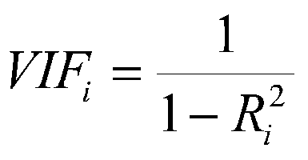
As a rule of thumb, values above 10 are seen as serious violations of multicollinearity.

Correlation matrix

From our linear model we can build a matrix of correlations, of each predictor with each other, using the X matrix of values in our data with the cor() function in R.

K-fold cross validation

This is a method of estimating the predictive power of a model when confronted with new data that wasn't included in the training. It works by splitting the data into k folds (in our case 10) and for each fold we create a model that is based only on the remaining k-1 folds. Then we attempt to predict the data not included in the model and compare it to the actual observation. The cross validation yields metrics for determining how well the models predict the data. They are RMSE, Rsquared and MAE. RMSE and MEA tell you how close your model's predictions are to actual data but RMSE is more weighted towards larger errors. Rsquared tells you how much of the variation in the data is explained by your model. A good value for Rsquared is closer to 1. The values of RMSE and MEA are better closer to 0 and are dependent on the range of your data.

Model Diagnostic and Prediction Plots:

The following are visual representation methods for determining the “health” of our data and models. They help analyze our data to determine how we can best alter our predictions. As well as confirm the accuracy of our results.

Normal plot

A key assumption of least-squares linear regression is that residuals are normally distributed. A Normal qq-plot provides a visual for how closely a sample of numerical data matches a normal distribution - the more linear the pattern of the dots, the closer the data are to being normal. A normal qq-plot of the residuals gives us an indication of how reasonable this assumption is.

Residual plot (Pearson)

Ordinary least squares regression assumes that given a value for each predictor variable, the response has a mean determined by those values and a variance that is the same for all values within the range of predictor values the model pertains to. Our fitted values are our estimates of the means. So when we plot the fitted values vs. residuals (actual minus fitted), we expect them to be centered around zero for all fitted values and to have roughly the same variability. For our model, we scaled the residuals by the standard error of the response to easily compare them across fitted values, similar to z-scores. There were a few outliers, but no residuals larger than two standard deviations. See figure 6.

Leverage plot (Standardized Residuals)

When dealing with regression models, we may also find that specific observations with high leverage may heavily influence our fit. While this is not necessarily the purpose of this project, we can investigate these notable observations by plotting a leverage plot. Here, standardized residuals are plotted against the leverage score of each observation and compared to Cook’s distance, which measures a point's influence when removed; the rule of thumb is that distances greater than 1 or 4/n are cause for investigation. It should be noted as well that the Standardized method differs from Pearson’s by scaling each residual by its individual leverage value (the diagonal of the Hat Matrix) rather than by response variation alone.

Added Variable Plots

One of the most essential parts of this analysis, along with ANOVA, is the use of added-variable plots. By plotting the residuals of our response from a regression that excludes the candidate variable against the residuals where the candidate is regressed on other predictors, we can essentially net away the influence of the covariates to find the partial regression between Y and some X. In other words, we sweep away some candidate variable to find the unexplained variance in Y without it, and plot that with the unexplained variance found in X from the other variables.

Variable selection:

Before finalizing our model variable choices, we would also want to run our base model past some stepwise regression functions to see how the automation selection would react.

AIC metric

The first variable selection method we used was the Akaike Information Criterion (AIC), which is a statistic that decreases with greater fitness of the model, but also increases with more predictor variables added to the model. Minimizing AIC is one technique to manage the tradeoff between parsimony and fitness.

Forward variable selection

This is a method for selecting the appropriate variable for a model. Starting with a black model (intercept) and slowly building up by inserting a new regressor in each step until a final model is achieved. New variables are added according to a specified test statistic (in this case AIC). The selection terminates once no variable can be added that improves our model.

Backward variable selection

This method works by starting with the complete model and in each step removing a regressor until a final model is reached. Determining which regressor will be removed depends on which test statistic we use (in this case AIC). The selection terminates once removing any variable will not improve our model.

Bi-directional variable selection

Similarly bi-directional selection works like forwards and backwards selection. With the notable difference that both adding and removing variables is permitted. We begin with a simple (intercept) model and advance by adding or removing variables. The next variable to be added or removed is determined by using a chosen text statistic. In every step the test statistic is determined for the addition or removal of every variable and the best result is selected for the next step. The selection terminates once adding or removing any variable will not improve our model.

Results

Initial Regression findings:

For the data, the fitted initial linear model is as follows:

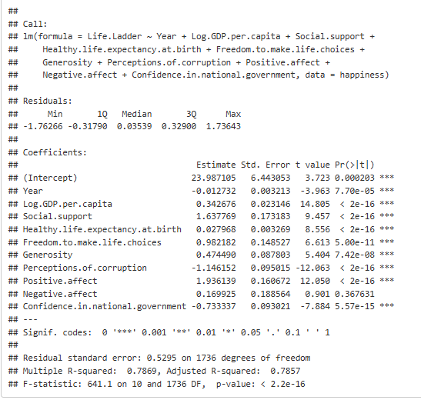

From this summary, we immediately find that, after accounting for the other predictors (Type-3 p-values), the Negative affect variable is not significant (p-value > 0.05) in predicting changes in the response variable, or put differently, that there is insufficient evidence to reject the null hypothesis that its beta coefficient is 0. Essentially, information about Negative affect is already captured by the rest of the model, and our summary suggests that it can be removed. The summary also reports that our model has an adjusted R-squared of 0.786 and a global F-statistic of 641.1 on 10 and 1736 DF, with a P-value < 2.2e-16, providing decent diagnostics for the explained error and rejecting the null hypothesis that all predictors have beta coefficients equal to 0.

Variable selection

Using forward selection, backward selection, and bi-directional selection based on minimizing the AIC resulted in every variable being kept except for negative affect. We have determined that the following variables are significant in predicting life-ladder:
GDP, Positive, Corruption, Support, Life Expectancy, Generosity, Confidence, Freedom, and Year. Thus, the only variable removed in every selection method used is Negative, most likely due to the fact that this information is already covered in the variable Positive effect.
The linear model we determined is most appropriate is the following (rounding to 2 decimal places):
Life Ladder = 22.53 +
0.34GDP + 1.93positive - 1.13corruption + 1.59Support + 0.03Life Expectancy + 0.48Genrosity - 0.74Confidence + 0.98freedom - 0.01Year + e

Most of the beta coefficients conform to expectations; however, the only surprising one is confidence in the national government, which is inversely correlated with Life Ladder (reported happiness) in the model. Additionally, the intercept is surprisingly high (22.53 for a 1-10 scale average).

Model Building and Testing

To dive deeper into our analysis, we’ll look to test different modeling and testing techniques. We’ll first exclude the country variable, since we are only interested in how the other factors (the numerical factors) might affect the differences in happiness between countries, and adding what would amount to an indicator variable for every individual country would undermine our investigation (as well as add 149 degrees of freedom to our model). Next, we’ll examine the scatterplot matrix of the 10 predictors to estimate any interactions between the variables roughly:

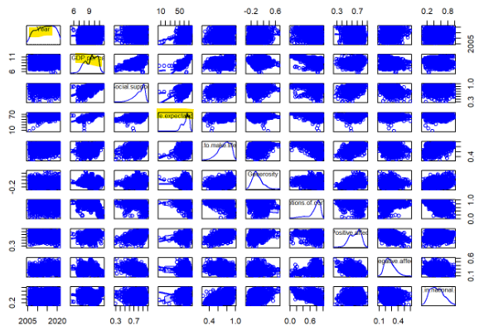
At first glance, there are noticeable patterns, particularly from variables interacting with GDP and Life Expectancy, as well as some non-patterns, or static, that were generated from interactions with the Year variable. As far as cursory data exploration goes, the scatterplot matrix is only good for a quick glance, but now we have some visual leads for the next steps of our model building.

Next, we performed an analysis of variance on our model:

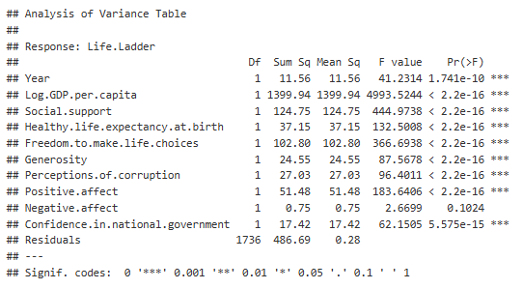

We can see that GDP provides the greatest reduction in error, with 1399 sums of squares, while Negative effect once again fails to add any meaningful information to the model. Along with this, we also see the other variables add between 10-100 sums of squares to the explained error. However, we must keep in mind that ANOVA performs these sequential tests in the order in which our model was created, so in this case, we started with Year and ended with Confidence. But as we’ll see shortly, there are other ways to measure redundancy and multicollinearity between predictors.

VIF results per the data:

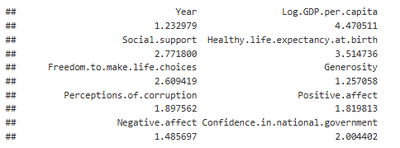

None of the variables seems too high in their variance inflation factors, though we should note relatively high values for GDP, Social Support, and Life expectancy, but none above 10. As we continue with our analysis, we’ll identify additional redundancy in the model and make appropriate variable selections.

Leverage plot results as per the data:
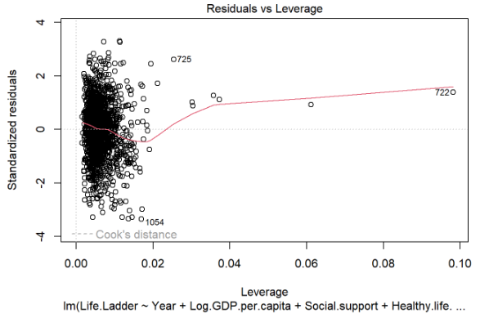

As seen above, while some points have more leverage than others, the overall leverage points range from 0 to 0.02, with none exceeding the default Cook’s distance. There is no cause for concern with outliers in this data.

For the X matrix in our data, we can use a simple cor() function in R to get the correlations between each predictor, as shown:

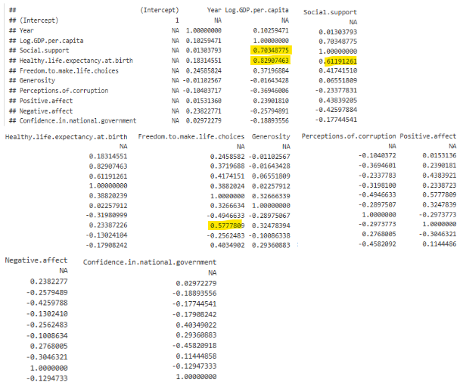

Looking across the different correlations, we find the highest to be between GDP and Social support (0.703), GDP and Life expectancy (0.829), Social support and Life expectancy (0.612), and Freedom and Positive affect (0.578). We won’t remove the GDP, Life Expectancy, or Social Status variables. We do this because, while they exhibit the strongest correlation, our earlier VIF values indicated that these variables did not present any serious multicollinearity effect, namely instability in the model or inflated SEs in coefficient estimates. Results from our fit summary support this decision as well, given the low variance estimates and stable p-values observed. On top of this, we should also consider the different information captured by these variables. We might say that the effect of social support is meaningfully different from that of national wealth or a nation's individual life expectancy. We may also posit that Life expectancy is meaningfully tied to medical care and the nation's ability to pay for it, and find cause there to remove it. But for now, we won’t, and we do this to take a measured approach to model building. There’s no need to bite off too much. And as we’ll see in a moment, there are other ways and reasons to remove a feature. It should also be noted that the highly correlated variables here will not negatively affect the predictive power of the reduced model, as seen in Fig. 2. So, for now, we’ll refine the correlation matrix to remove the intercept to summarize the mean correlation of each predictor for each interaction:

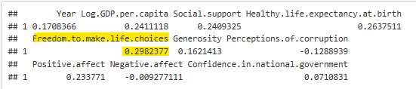

What is immediately evident is that Freedom has the highest average correlation, followed by life expectancy, GDP, and Social Support. Looking back at our ANOVA, we may be interested to see the effect of this removal, given its somewhat high sums of squares and high overall correlation. But more importantly, Freedom is a national average between 0 and 1 for dissatisfied vs satisfied, and is part of the more abstract survey data. The same goes for Generosity, Social Support, Perceptions of Corruption, Positive and Negative affect, and Confidence in the Government. As we examine these variables, some information may already be captured in similar categories: Positive and negative affect, Generosity and Social support, and Perceptions of freedom and trust in the government. While we continue running diagnostics, we should consider which variables contain the most pertinent information and which are more closely related than others.

Now we’ll examine the Added Variable Plots, which greatly help to identify variables that contribute to the response and those which are noise:
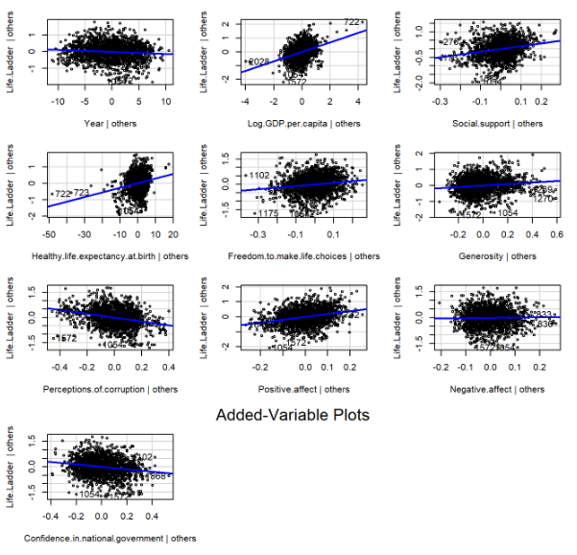

As can be seen, the AV plots with near-0 influence or slope correspond to the variables that offer the least to the model. And while we necessarily saw these slopes earlier as coefficient estimates, here we get a clearer picture of which variables will not help us build an accurate model. Combining this with our correlation matrix and previous selection methods, we now have a good idea of which variables to eliminate: Year, Negative affect, Freedom, and Generosity. While not as correlated as Freedom, Generosity was chosen due to its near-zero influence and similarity to Social Support. Later, we can check how well our subset model performs by using ANOVA to examine the extra sums of squares.

Subset Model:

We can now begin to subset our model using our earlier findings, removing Year, Negative affect, Freedom, and Generosity. The summary of the fit follows:

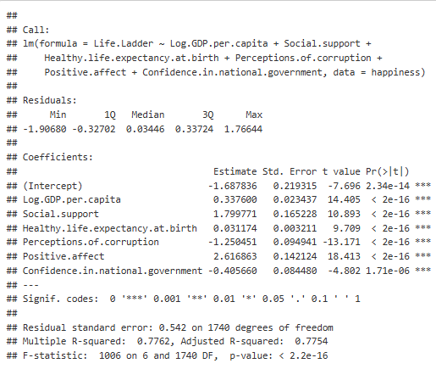

All Type-3 p-values are insignificant with an adjusted R-squared equal to 0.775, and an F-statistic of 1006 on 6 and 1740 DF with a P-value < 2.2e-16.

These results yield the following model:
Life Ladder = -1.69 +
0.34GDP + 2.62positive - 1.25corruption + 1.80Support + 0.03Life Expectancy
- 0.41Confidence + e
In the reduced model, most of the results conform to the original model with a few notable changes. The intercept is now -1.69, reasonably closer to the expected range. Yet confidence in national government is still negatively correlated with Life Ladder (reported happiness), but by a smaller factor, -0.41 vs -0.74. This makes sense, as higher levels of corruption should be associated with lower levels of happiness.

Extra Sums of Squares

Finally, in an analysis of the extra sums of squares gained by reducing our model, we get the following output from ANOVA:

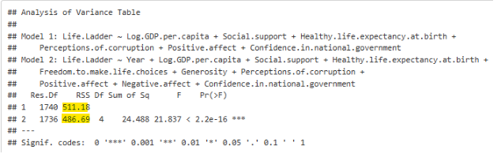

It was found that the p-value for the partial f-statistic is significant, implying that the full model is better not due to random chance (adj. R-squared 0.786 vs. 0.775). But this is the case for only a 0.009 improvement in the full model's error. From our partial F-test, we also see that only 24.5 sums of squares are reduced by the full model with an additional 4 degrees of freedom. Compared to the total sums of squares from our ANOVA earlier, those four variables had 139 sums of squares. Putting this together, with parsimony in mind, the reduced model is better due to its simpler design and near-negligible increase in error.

K-fold cross validation

Lastly, we performed k-fold cross validation on our model to validate its predictive power when confronted with new data. Here are the results:
Linear Regression

1747 samples
6 predictor

No pre-processing
Resampling: Cross-Validated (10 fold)
Summary of sample sizes: 1573, 1572, 1572, 1571, 1573, 1573, ...
Resampling results:

RMSE Rsquared MAE
0.5425099 0.77571 0.4176809

Normalizing the RMSE and MAE cross validation parameters relative to the range of our data we get 0.094 and 0.072 respectively. This means that our model has very good predictive power with under 10% error. And both parameters being close to each other means that there aren't many large outlier errors in our predictions.

Model Diagnostic and Prediction Plots

Figure 1
Fitted vs actual values (base model)
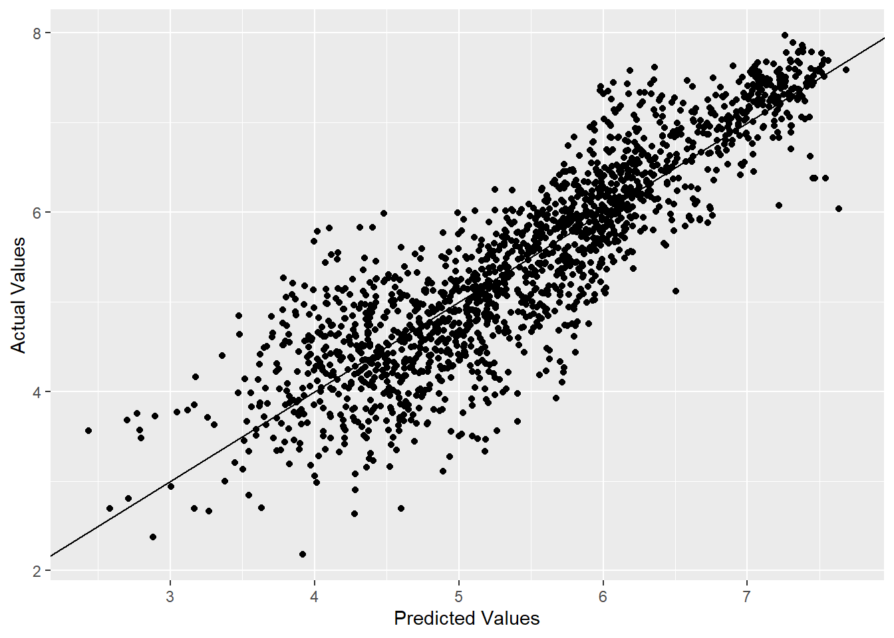
Figure 2
Fitted vs actual values (reduced model)
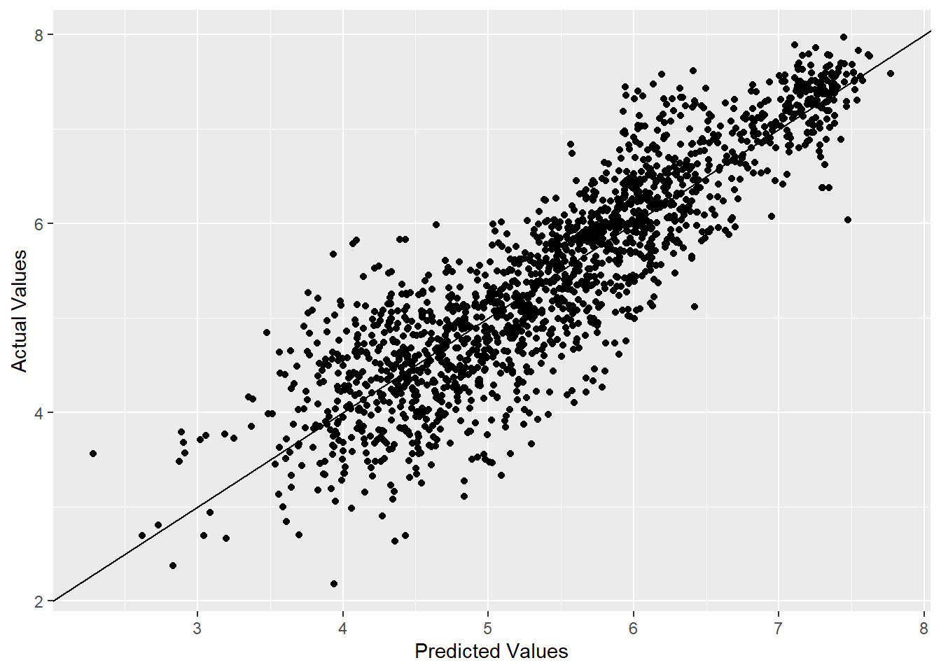

Figure 3
Residual Plot (reduced model)
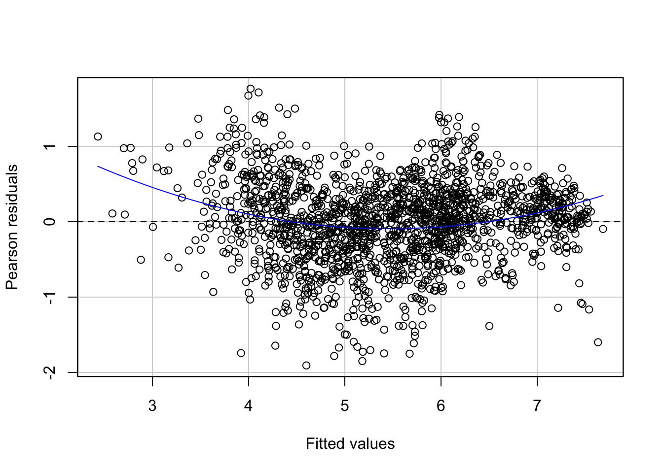

Figure 4
Leverage Plot (reduced model)
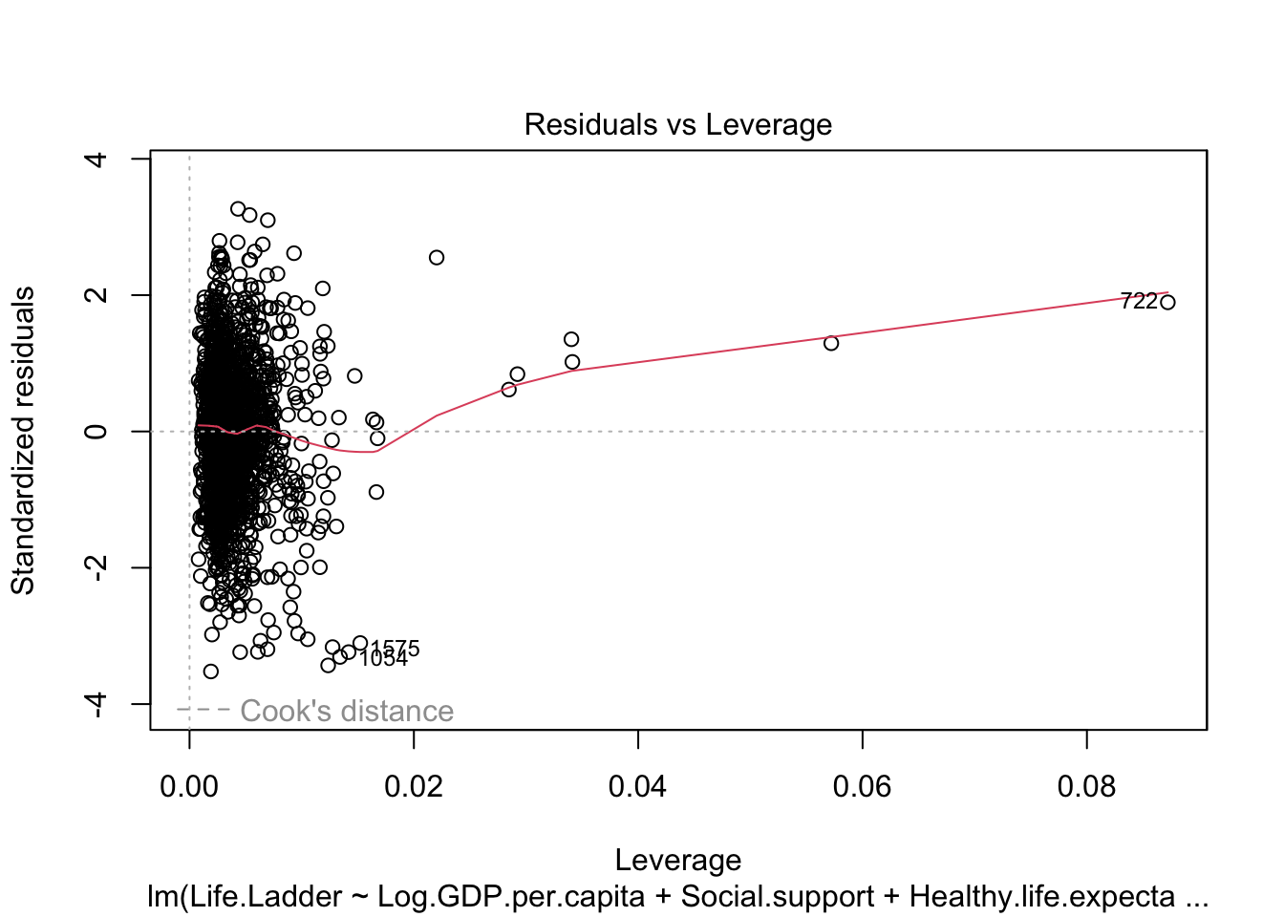

Figure 5
Normal Q-Q plot (base and reduced model)
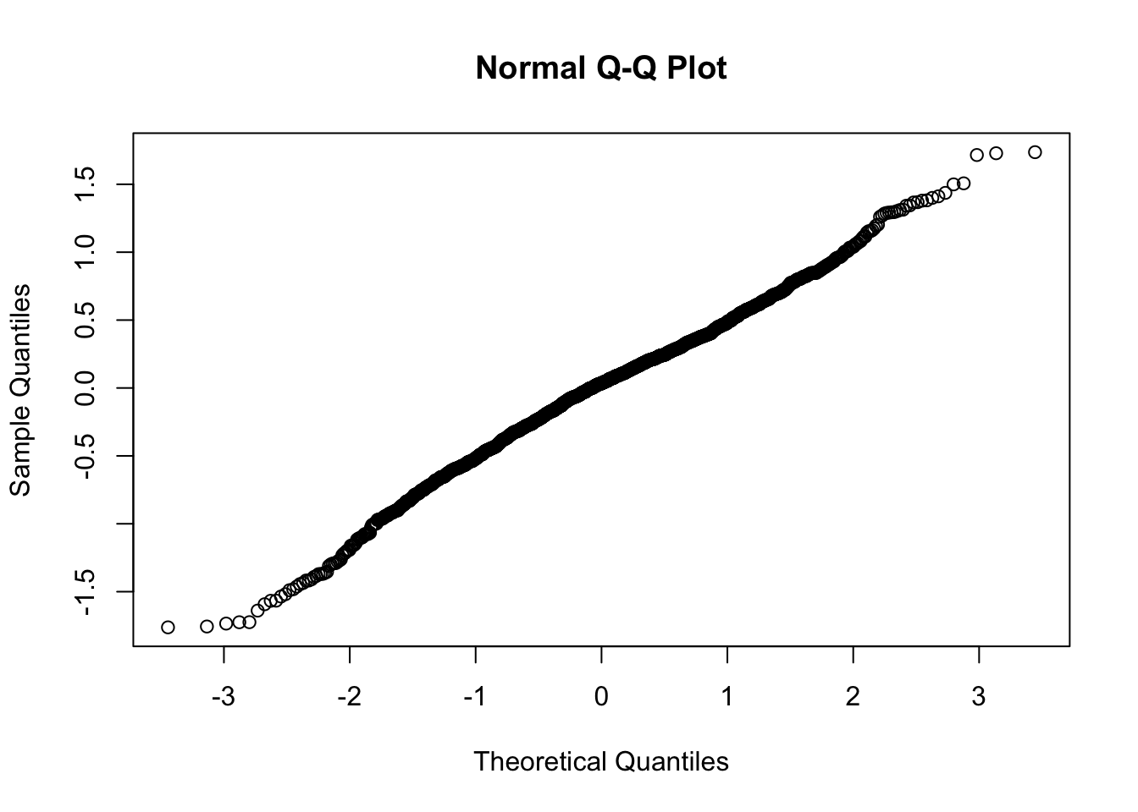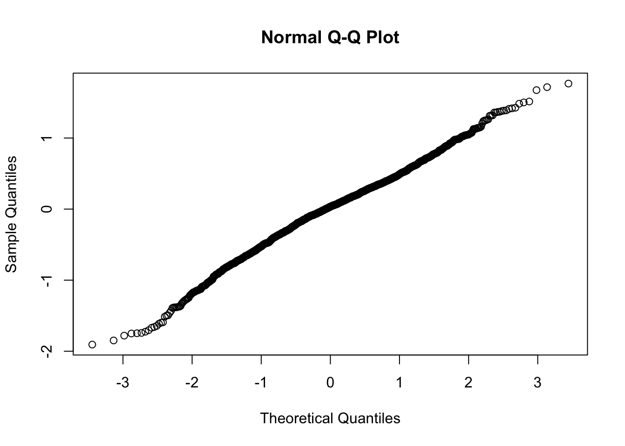

Linear plots indicate normally distributed errors.

Figure 6
Residual plot (full model):
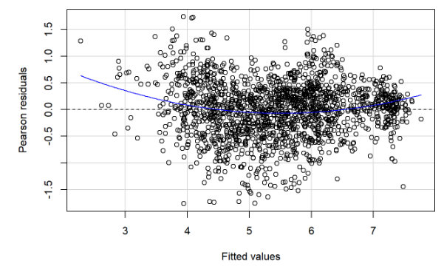

Additional Tables and Figures (for discussion)

Table 7
The following table gives the total number of data points in the original dataset for each of these countries (Total.obs) as well as the number that had a missing value for each of four variables (first 4 columns)
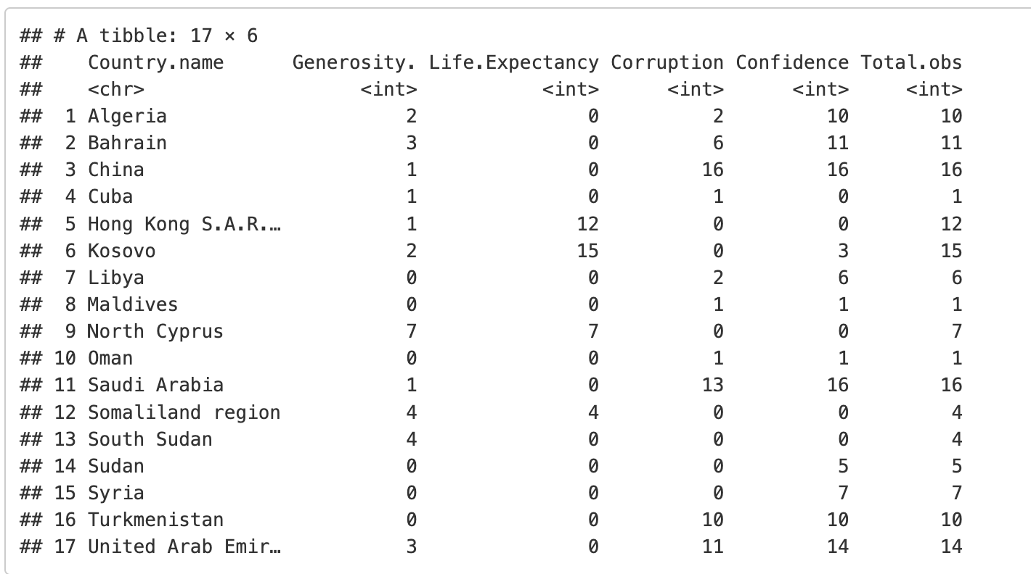

Figure 8
This is a plot of the maximum vs minimum residual from our reduced model of each country. In other words, each point represents a country, and its x-coordinate is the residual from the year when our model most overestimates the country’s happiness level and y-coordinate is the residual from the year when our model most underestimates the happiness level. Countries with only 1 complete data point are excluded. 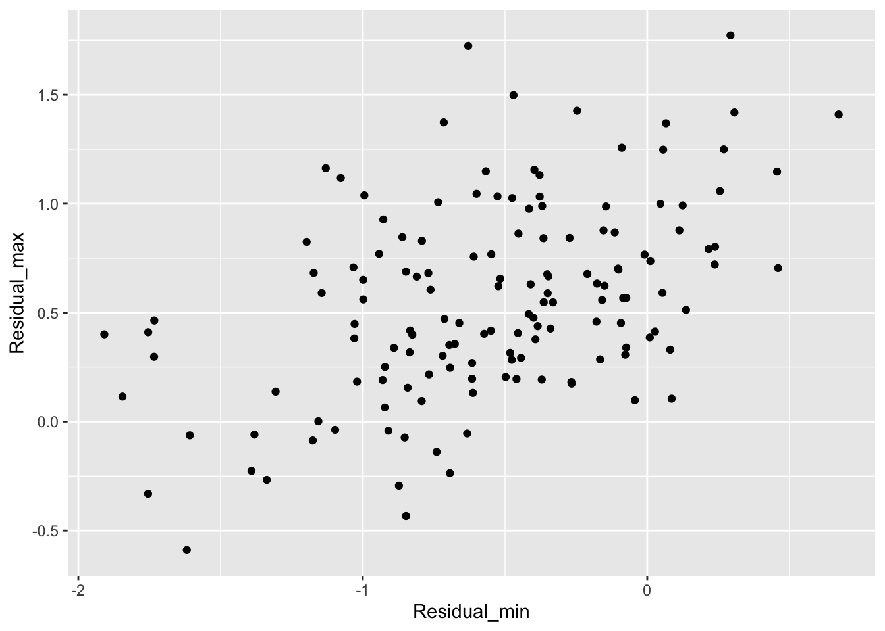

Discussion

-In this exposition we sought out to explore the question of what factors influence people's perception of happiness around the world. To begin we used the world happiness report which includes data about several life factors and reported happiness in each country across several years. To examine this data properly we cleaned it for missing values and created a linear model for Life Ladder vs the remaining variables. Then we applied several statistical methods to determine which variables are most appropriate for our analysis. Including variable selection methods, analysis of variance, VIF, correlation and scatterplot matrices. We used insights from these tests to build a reduced linear model and verified our new model using subset testing with ANOVA, normal and residual plots, leverage points and k-fold cross validation.
-The results of our analysis determine that the following life factors are significant in determining the perception of happiness as measured per country; GDP, life expectancy, social support, positive emotions, perception of corruption and confidence in government. Not surprisingly the most significant factor appears to be GDP which suggests that financial security is an integral part of human perception of happiness. The second most significant factor was life expectancy, which as expected shorter life expectancies usually arise because of bad conditions so there is no surprise that it is significant in determining perception of happiness. We found that while there is some correlation between GDP, life expectancy, and social support, these variables are all separable enough that a difference in one without a difference in the other two can still be expected to lead to a difference in happiness .
-Overall our model is very good at predicting the perception of happiness. As with regrets to the use of different statistical methods we found that some were more insightful than others in our case. Stepwise variable selection methods didn't yield anything we didn't know from a simple model summary. On the other hand the scatterplot matrix and particularly the added variable plot was most helpful in determining which variables to discard. Also variance inflation factor and k-fold cross validation were useful in interpreting our results.
-One surprising result of our analysis is that in every method we used the experience negative emotions did not impact perception of happiness significantly. The best explanation we have for this phenomena is that the effect of negative emotion is already accounted for by the other factors, especially the experience of positive emotions. Although, positive affect and negative affect do not present high levels of multicollinearity and the explanatory power of negative emotion on perception of happiness is present. Another surprising result is that confidence in government is negatively correlated with happiness. We are unclear as to why.

Limitations and further research suggestions:

-One limitation of our study is that we excluded all data points with any missing values. This led to the exclusion of 17 entire countries, each of which had at least one variable that it was missing for every year. See Table 7. All of the countries have no recorded value for at least one of these, with the majority (11) not having any value for confidence in national government.
This may be a reason why this variable isn’t as used by the World Happiness Report as the others. See for example the dashboard section of the WHR website, which allows users to interact with charts pertaining to each of our variables except for confidence. Another reason for this exclusion could be, as we found in our analysis, that the association between confidence and happiness appears to be negative from the data. Is coefficient negative in both of our models, the overall correlation between happiness and confidence in the dataset is -0.083- small, but negative and not obviously negligible. Causation analysis would be required to determine whether this association really means anything.
-Another limitation of this study is that data is collected in surveys and divided by country which poses 3 issues. First this means that countries with vastly different populations carry the same weight in the data, and so the data doesn’t proportionately represent the human population. Second, aggregating results by country limits our ability to more accurately discern which factors are involved in a person's perceived happiness. For both of these reasons, our results should only be applied to national populations and not to the global population, or to individuals. If a study did seek to analyze how factors such as social support and positive or negative emotions affect people on a one-to-one basis, it might collect data from an international random sample and use every response as an observation. Additionally it would probably be more reliable if other quantifiable personal aspects are collected (such as age, weight relationship status etc).
-The third issue is that it calls into question the assumption that the residuals are independent. Figure 8 illustrates this. The higher the lowest residual from a country is in our reduced model, the higher the highest residual from that country tends to be. The correlation is 0.468 (for the full model it’s 0.423). For our analysis, this means that while the variables we studied do a remarkably good job at explaining the overall differences in happiness between countries over the 2005-2021 time span, they don’t account for the entirety of those differences, and so there is more research to be done about what factors explain why some countries are happier than others.

Team Contributions

Alexander Galvan - Provided the code and analysis for base and reduced models, correlation matrix, ANOVA, scatterplot matrix, AV plots, and some diagnostics, and Abstract. Helped finalize the report.
Calvin Peloso- Selected the dataset, did research on the WHR and variable meanings, and provided code for QQ plots, Table 7, and min residual vs max residual plot. Wrote parts of the discussion section as well as some method descriptions.
Josef ulman - provide additional statistical analysis, outlined, formatted and edited the paper. Wrote parts of the introduction, methods, results and discussion sections.

References

Data: “https://www.kaggle.com/datasets/jahaidulislam/world-happiness-report-2005-2021”
Citations: “Introduction to Linear Regression Analysis by Douglas C. Montgomery, Elizabeth A. Peck, and G. Geoffrey Vining”
“Regression Methods course notes Professor Jack Mardekian.”
“The World Happiness Report dashboard, Gallup Analytics https://data.worldhappiness.report/map”
“World Happiness Report 2025, Statistical Appendix for 'Caring and sharing: Global analysis of happiness and kindness,’ Chapter 2 in World Happiness Report 2025, John F. Helliwell, Lara B.Aknin, Haifang Huang, Max Norton, Shun Wang, Felix Cheung, Yeeun Archer Lee, and Sara Konrath https://files.worldhappiness.report/WHR25_Ch02_Appendix_B.pdf ”
“Statistical Appendix for “The social foundations of world happiness”, John F. Helliwell, Haifang Huang and Shun Wang, Chapter 2, World Happiness Report 2017 https://files.worldhappiness.report/WHR17_Statistical_Appendix.pdf?_gl=1*1df68x3*_gcl_au*ODE1ODE1NTU3LjE3NjQ1NTYzMzM. ”
March 10, 2025
Code: “Regression Methods Final Project.Rmd”*
“Regression Methods Final Project.pdf”*
*attached

